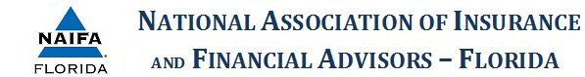
NAIFA-Florida Speaker Bureau Registration Form

Name (Person completing the form):
Michael Halloran
Address
6054 San Jose Blvd
Jacksonville, Florida 32217
United States
Map It
Prefered Contact Information
phone
Phone
(904) 399-8308
Email
mike.halloran@nm.com
Recommended Speaker Name
Mike Halloran
Address
same as above
United States
Map It
Preferred Contact Information
same as above
Title
Wealth Management Advisor
Length of Presentation
1/2 hour to 4 hours
Location/Region Available:
no more than a 3 hour drive unless group is paying for a plane flight
Equipment/AV Needs
computer, screen, projector
Additional Information/Questions
Bio and talks list will follow.

